**Design Synopsis for Library Management System**

**Purpose:**

The purpose of this project is to develop a system to manage a school's library efficiently. The system will handle book inventory, student and teacher records, and borrowing and returning processes.

**Functional Requirements**

1. **User Management**:
   * Admin Login
   * Librarian Login
   * Student Login
2. **Book Management**:
   * Add/Update/Delete Books
   * Search Books by Title, Author, Genre, etc.
   * Track Book Availability
3. **Member Management**:
   * Add/Update/Delete Student and Teacher Records
   * Manage Member Accounts
4. **Transaction Management**:
   * Issue Books
   * Return Books
   * Track Due Dates and Overdue Fees
5. **Reporting**:
   * Generate Reports on Issued Books, Available Books, and Late Returns

**High-Level Design Diagram**

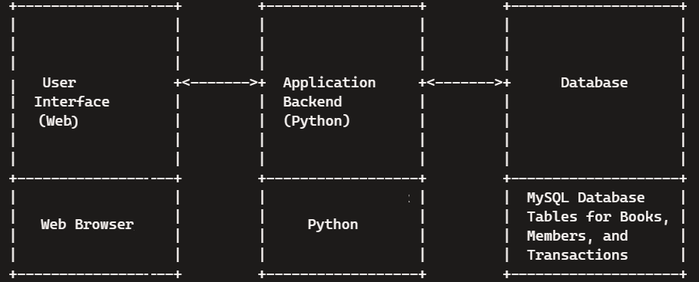

**Components**

1. **Database (MySQL)**:
   * Tables for storing book details, member records, and transaction logs.
2. **Application Backend (Python)**:
   * Handling business logic, database interactions, and user authentication.
3. **User Interface (Web)**:
   * Providing a user-friendly interface for librarians, students, and admins to interact with the system.

**Database Design:**

**Table: teachers**

**Table: students**

**teacher_id (PK)**

teacher_name

teacher_email

**student_id (PK)**

student_name

student_grade

student_section

**Table: books**

**Table: transactions**

**book_id (PK)**

book_title

book_author

book_subject

book_availability

**transaction_id (PK)**

book_id (FK)

member_id (FK)

issue_date

return_date

**Table: administrators**

**Table: librarians**

**admin_id (PK)** admin_name

admin_email

**librarian_id (PK)**

librarian_name

librarian_email

* **PK**: Primary Key, **FK**: Foreign Key

**students:** This entity stores information about the students who can borrow books.

**teachers:** This entity stores information about the teachers who can borrow books.

**books:** This entity contains details about the books in the library.

**transactions:** This entity logs the borrowing and returning of books. It has foreign keys to the Books and Students/Teachers entities to track which book is issued to which member.

**librarians:** This entity contains details about the librarians who manage the library.

**administrators:** This entity contains details about the administrators who oversee the library management system.

The transactions table links books and members (students or teachers), enabling the system to track which books are issued, due, or returned.

Only admin is allowed to insert/update/delete records to table students, teachers and books.

Actions from the librarian willinsert/update/delete records in the transactions.